**CMPT-416N – Cybersecurity**

**Syllabus updated – August 24, 2020**

**Andrew Tokash**

**Hancock 2019 : Monday and Thursday 12:30-1:35   
 Webx or 2019 : Some Saturdays 12:30-1:35**

**Faculty Availability**

Office Hours: **Hancock 3002 – Office Hours will meet via WEBX meetings!**

* Mondays, Tuesdays and Thursdays 9:30-11:30
* You can schedule an appointment via: [calendly.com/atokash](http://www.google.com/url?q=http%3A%2F%2Fcalendly.com%2Fatokash&sa=D&sntz=1&usg=AFQjCNEi_Tw-l0_wVOhhsK4Wt8TEGIZXzw)

**Please use iLearn messaging for all communications.** (Do not use Marist e-mail.)

There is also an iLearn forum for general questions on material, expectations, etc.

**Introduction**

This course is required for Cybersecurity major/minor degrees and provides the foundation for further studies. It’s an excellent course for other CompSci students as you’ll learn the basics of protecting software and hardware. And it’s an important course for non-CompSci majors also; knowing cybersecurity is a skill almost all employers value.

It’s also beneficial for your personal life: How do you know if a wifi network is secure? What should you do if you get an ‘expired digital certificate’ message? How do you know if an e-mail is real or spoofed? How can you protect your data and yourself in the digital world?

**Catalog Course Description**

This course provides an introduction and overview of key concepts in cybersecurity for cloud and enterprise data centers.  We provide a framework for understanding cybersecurity concepts based on the NIST cybersecurity lifecycle.  Students will be introduced to core concepts including physical data center security, authentication, access control, identity management, secure software development principles and practice, cryptography, cloud and mobile device security, security compliance and governance.  Students will be introduced to a variety of common security attacks, including code injection, man-in-the-middle, phishing, buffer overflows, and adjacency attacks.  Using a self-contained lab environment, isolated from the campus network and the Internet, students will be able to practice common hacks and defense strategies, and learn how to scan websites and cloud environments for security vulnerabilities.  Practical examples of real world security breaches will be used as case studies to illustrate key concepts.

**Prerequisites**

* CMPT-120 : I expect college level work. All submissions and presentations should be proofed and professional. Submissions should be properly formatted.
* CMPT-306 and 307 – We’ll be (re-)covering some of what you learned in Data Communications and internetworking, but reviewing and refreshing that material would be a bonus.
* Number Systems – You needed to know binary and hex and ASCII for both Data Communications and Internetworking. You’re going to need that again. If you are not 100% comfortable with these, there are many online tools to help you.

**NOTE: Students are expected to spend at least two hours of outside time for each one hour of class time! This is a 4-credit course; students are expected to work on labs during non-class time.**

**Notes on the “Flexible Hybrid” Course Offering**

This course will use the “Flexible Hybrid” offering.

* Lecture material will be provided via videos (available on the ILearn site).
* The students will be split into two groups. One group - half the students - will meet in the classroom one day a week, the other group will meet on the alternate day of the week. Note: the meeting day for each group is NOT fixed and you must be available for both time slots.
* Some Saturdays will be used as additional class days. These Saturday classes may be WEBX meetings required for ALL students, or they will be a classroom meeting for one of the groups.

***I will provide a weekly “Read Me First” file that will list meeting times, videos to view, due dates, and other information.***

**Educational Approach / Philosophy of Education**

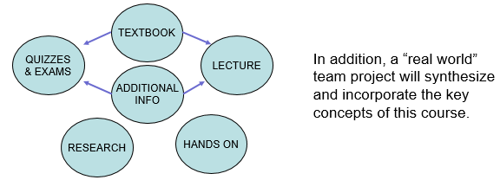

**Required Text and Resources**

* **Elementary Information Security by Richard E. Smith (3nd edition, 2019, Jones & Bartlett).**
* The course uses an online cloud-based lab environment that is required for the course.   
   ISBN for print book & labs: 9781284214741.   
   ISBN for ebook and labs: 9781284320930.
* Additional course materials may be provided in class by the instructor. Materials used in connection with this course may be subject to copyright protections
* Non-textbook material will also be presented on lecture slides. I strongly advise students to take notes!
* Please refer to my website for links to articles, videos, and other resources   
   https://sites.google.com/view/andrewtokash/home

**Labs – Team Activities**

New labs will be assigned almost weekly, with students also working in teams. The labs will be based on the bundled software. Each team must create a PPT lab report/presentation. While there will be one lab report for each team, each person must submit the (same) report in iLearn for grading. For each lab one or two teams will be asked to present to the class, with each team member presenting a portion of the presentation.

Refer to the “Lab Software Access” file in our resources for more details.

**Note: To ensure labs are graded properly, each slide should have the author noted on the bottom.**

**Computer Science Department Goals**

*“Today, companies expect not only technical hard skills, but also so-called professional skills [which] include communication, project management, conflict management, diversity management and teamwork.”* – Marc-Oliver Pahl

1. Prepare students for employment in a technology field or for graduate study in a technology field.
2. Provide students with both theoretical knowledge and skills-based proficiencies in the five core technology competencies: programming, hardware, data communications, data management, and systems/software analysis and design.
3. Provide students with fundamental knowledge of business administration and management so that graduates will be able to work effectively within businesses and other organizations.
4. Develop interpersonal skills for working effectively on teams.
5. Develop effective written and oral communication skills.

**Course Objectives[1]**

1. Understand computer security, white- and black-hat hacking, Google hacking, vulnerabilities, etc. [1,2]
2. Understand computer and file access controls and demonstrate how to set controls on the Windows operating system. [1,2]
3. Understand both symmetric and asymmetric encryption techniques. [1,2]
4. Understand computer networking, including both the security implications and business management controls. [1,2,3]
5. Understand the operation and security requirements for computer applications and the Internet. [1,2,3]
6. Understand cybersecurity’s legal requirements and the ethical dimensions. [3]
7. Perform simulated computer sessions using state-of-the art security tools. [1,2,3]
8. Research a real-world security breach; develop and present a comprehensive security report. [1,2,3,4,5]
9. Work in teams on lab assignments and class presentations. [1,2,3,4,5]
10. Submit professional module and lab assignments. [5]

In summary, my main objectives are to (a) have you truly learn the material, and (b) prepare you for employment in the IT field.

A detailed list of ‘core competencies’ is listed in the iLearn resources (file “Class Notes”). This list details, by weekly module, expected acquired knowledge topics and demonstratable skills.

Note: Due to the pandemic we’re forced to incorporate online instruction and online team-work. While this has some drawbacks, it also prepares students for the modern workforce, which more and more include remote employees and online team projects.

**Coursework Submission Guidelines**

Assignment, lab and project files must be submitted into ILearn. Documents must follow a standard naming convention and have proper page headers. Refer to the file “Submission Guidelines” in the Ilearn Resources section.

The guidelines file also lists information on using/citing references and the difference between a 90% A and a 100% A.

**Course Evaluation**

Students are assessed through exams, self-assessment quizzes, assignments, presentations and projects. Written projects and presentations will be used to assess their interpersonal, written and oral skills.

20% Weekly Lab Assignments (team)

15% Self Assessment Quizzes

30% Exams

20% Assignments

10% Team Case Study

5% Class Attendance & Participation

The aggregate grading policy for midterm and final grades will be the standard Marist grading system, and will be displayed in the iLearn gradebook.

**All assignments are to be submitted by the due date specified.** Make-up opportunities for assignments, assessments, and exams are provided only for verifiable extenuating circumstances cleared through CAAS. Acceptable excuses for late submission of assignments include situations covered in the Student-Athlete Handbook, illness, and serious extenuating circumstances (e.g., death in the family, serious illness).

NOTE: I generally do not provide extra-credit or make-up assignments.

**Academic Honesty**

Faculty will uphold and enforce the general policies of this institution on academic honesty and plagiarism. All examinations, assignments, and projects are subject to the standards of academic honesty as described in the Student Handbook and/or other related publications.

Neither plagiarism not cheating will be tolerated. If you are suspected of cheating, you will be asked to explain the work. If you cannot you will be ejected from the course with a failing grade, in addition to any other forms of recourse available to the instructor as specified by the Student Handbook.

You are encouraged to discuss the course material, concepts, and lessons with other students in the class. However, your labs, exams and discussions must be your own work. If you are caught copying or otherwise submitting material that is not solely your work, you will fail the course and a letter will be sent to the department chair.

Please consult the ACM code of ethics. See [www.acm.org/constitution/code.html](http://www.acm.org/constitution/code.html).

**Semester schedule**

Below is the tentative initial semester schedule. It is a work in progress and will change through the semester. I will keep iLearn updated and will display it at the start of each class.



**Learning Disabilities**

Students have all types of learning disabilities. It is your responsibility to notify the professor in the beginning of the semester in order to make sure you are successful within this course! If you’re unsure whether you have a learning disability, make sure you see Special Services within Donnelly as soon as you suspect your disability!

**The “Read Me First” File**

As mentioned above, Ilearn will have a READ ME FIRST file with to-do’s and schedule, team breakdown, core competencies, and other information.

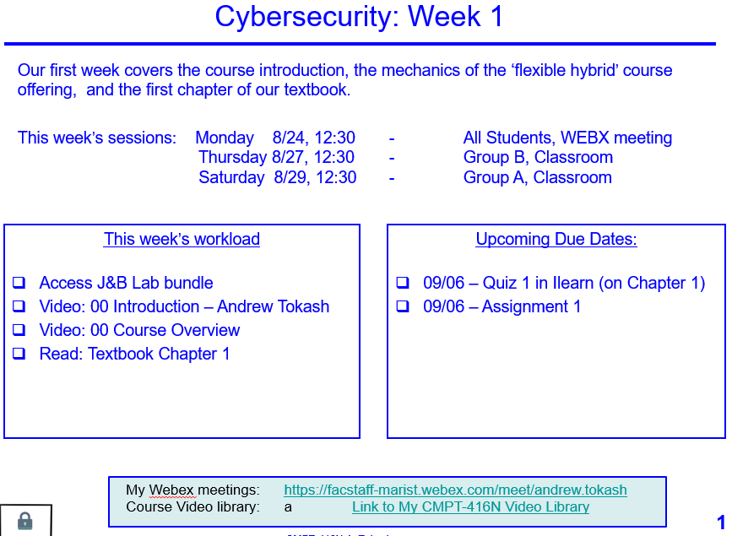 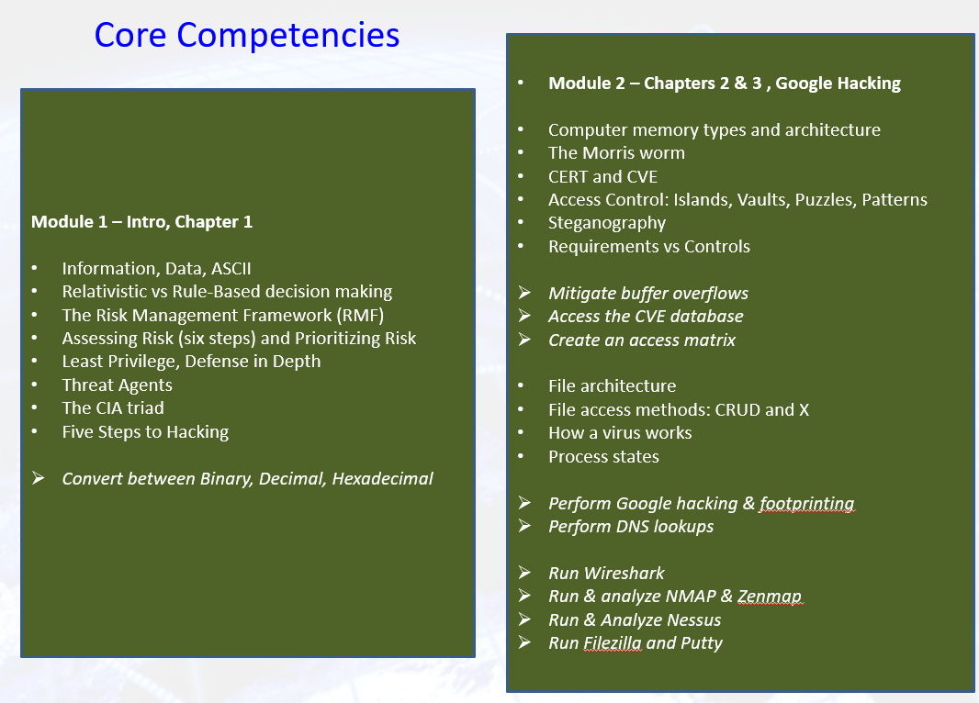

**Steps to Getting an “A”**

1. Attend classes. If something is unclear ASK for a better/different explanation.
2. Be an active student. Take notes, listen, speak, ask questions.

Refer to: http://www.dartmouth.edu/~acskills/success/notes.html

1. Do a quick review of chapters BEFORE the class to identify confusing sections.
2. Read the chapter and review each section’s TEST YOUR UNDERSTANDING questions.
3. Do all assignments and submit them on time with proper formatting and citations. Begin assignments early in case you have questions.
4. Do not copy assignments from other students, the Internet or any other source.
5. Take your time with SELF ASSESSMENTS. Review material BEFORE taking the quiz.
6. Study for the exams. Use the Core Competencies as a study guide.
7. Work with other students and take advantage of office hours.
8. Monitor your grades weekly.
9. Use a flashcard application (ex: Quizlet) to help you study.
10. Participate fully in team projects!
11. If you have any questions, confusion or issue, address them immediately. Do not wait until the end of the semester to do so.

**Changes to This Syllabus**

08/12/2020 Original syllabus

08/20/2020 Changed office hours   
08/23/2020 Add office hours scheduling link, Added some minor other information

*End of Document*

1. The reference number in brackets [ ] indicates the department goal that is being met with the fulfillment of the objective.